Add a Fee Schedule

Function: This dialogue allows the user to create multiple fee schedules in the Org. These fee schedules can be associated with physicians, locations or payers. It is in the fee schedule that a fee is defined for a given procedure code. This is the fee that will display on the HCFA and calculate on Accounting Reports. For instance, a multi-specialty practice could set up a fee schedule for each specialty and attach physicians to that fee schedule or a multi-location group could set up fee schedules by locations.

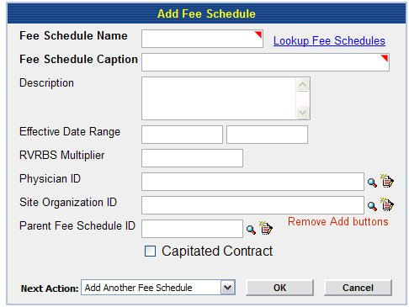
Fig 1a

Remove:
- From Physician ID, Site Organization and Parent Fee Schedule
Edit:
- Lookup Fee Schedule should be consistent with other dialogues, whether a hyperlink on words is used or icon.
- Example of format for RVRBS should be indicated to right of field
- If Fee Schedule Name cannot include spaces, the application should automatically omit spaces entered when user is entering Fee Schedule Name.

Description of fields
Fee Schedule Name: If this ID is unique and requires a certain format, the application should automatically format what the user enters. For example, user enters “Main Fee Schedule” and the application requires all caps and no spaces, the application should enter “MAINFEESCHEDULE”
Fee Schedule Caption: This is a free text field.
Description: This is a free text field.
Effective Date Range: If this should be in a certain format, that should be noted near the field. This allows the user to “turn on” or “turn off” a fee schedule by entering dates. If the user enters a beginning date, the ending date should not be required. Once a user enters an end date the application should not use that fee schedule. If a product, physician or location is tied to it, and a claim is entered, the application should go back to the default fee schedule “FFS”.
RVRBS: If this field has a certain format, the dialogue should have an example of that format near the field. This is used to calculate Fees based on a percentage of RVRBS.
Physician ID: The user may enter a physician or several physicians that utilize this particular fee schedule. Once the user enters the physicians, they should have the ability to view these physicians and add/edit at anytime.
Site Organization: The user may enter a location or several locations (known in application as Associate Providers) that utilize this particular fee schedule. Once the user enters the physicians, they should have the ability to view theses locations and add/edit at anytime.
Parent Fee Schedule: The user may enter a fee schedule that is the parent fee schedule. For example, the default fee schedules maybe 90% correct for a certain physician but some fees for certain codes are different. The user can different these fees in this child fee schedule. The application should only allow for one Parent Fee Schedule.
Capitated Contract: The user may choose to make a fee schedule capitated. In other words, when the user enters a claim against a capitated contract, the fee amount of each fee schedule item is adjusted off account, except for those items, which have been marked as fee-for-service in the fee schedule.

Action Codes

Lookup Fee Schedules
User should be able to look up existing Fee schedules to ensure they are not duplicating an existing fee schedule. The lookup should either be an icon or hyperlink on the wording “Lookup Fee Schedule”. A search engine should display in new window.

Look up Fee Schedule: This look up takes user to a search engine for an existing Fee schedule. The user should be able to pull up using the following criteria:
Fee Schedule Name, Fee Schedule ID, Description, Physicians linked to Fee Schedule, Locations linked to Fee schedule
Fee Schedule Name
Fee Schedule ID | **User enters ID
Description
Associated Physicians | **User enters ID(s)
Associated Site Organizations | **User enters ID(s)

Once user clicks [OK]→application pulls up results:

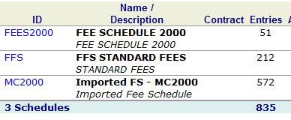

- User clicks look up→application takes user to search engine→user clicks Name/Description (Fee Schedule 2000)→application takes user to details of fee schedule
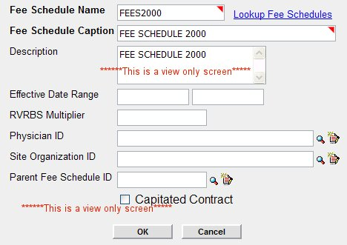
This is a view only screen. (This allows user to view details of an existing fee schedule if they believe the fee schedule they are creating already exists.)→User closes screen→application takes user back to results→user closes results window→application takes user back to Add-a-Fee Schedule Dialogue.

Or
- User clicks look up→application takes user to search engine→user clicks ID→application pops up error screen stating “Fee schedule already exists in [Org id]” and [OK] button→ User clicks [OK]→ application takes user back to blank Add-a-Fee Schedule Dialogue

Look up an Existing Physician: This lookup, whether an icon (magnifying glass or the words are a hyperlink) should take user to a search dialogue which allows the user to search for an existing Physician ID—see below. ***Note the method chosen for lookup should stay consistent throughout the application. **

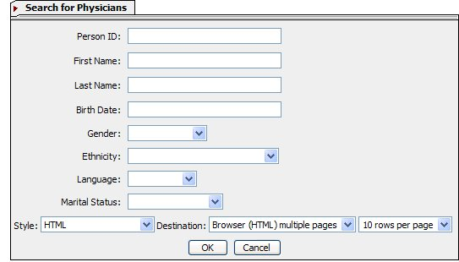

Add

- If birth date has to be in a certain format, then to the left of the Birth date box, should be a message stating the format (mmddyyyy). **Note: Anywhere in the application, where information should be entered in a certain format, there should be a small example of it near the field.

Once the user clicks OK, the system should pull up the results. See below. ***Note: Search results include only physicians..

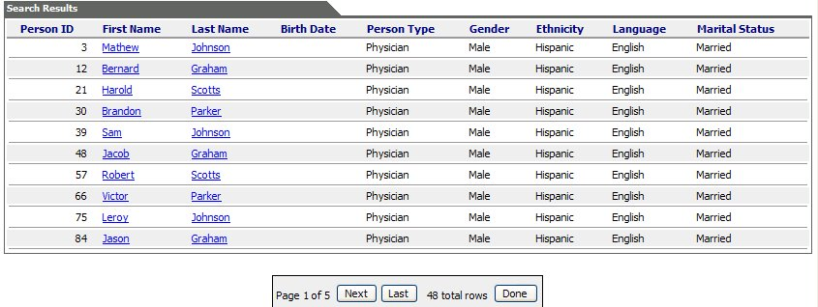

Edit

- The Person Id should be the item chosen to pull Person ID into field for Physician ID in the Add-a-Fee Schedule Dialogue.
- Switch Last Name column with First Name Column
- Sort in alphabetical order by Last Name.
- Only persons listed as Physicians should appear in results.

Look up a Site Organization: This lookup, whether an icon (magnifying glass or the words are a hyperlink) should take user to a search dialogue which allows the user to search for an existing Associated Organization. This should only list other Associated orgs and the Main org.—see below. ***Note the method chosen for lookup should stay consistent throughout the application. **
When the user clicks the symbol or the hyperlink, it should take them to a search engine.

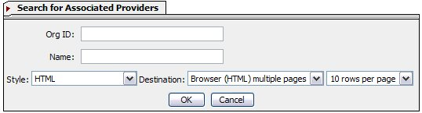

The results should consist of the following:

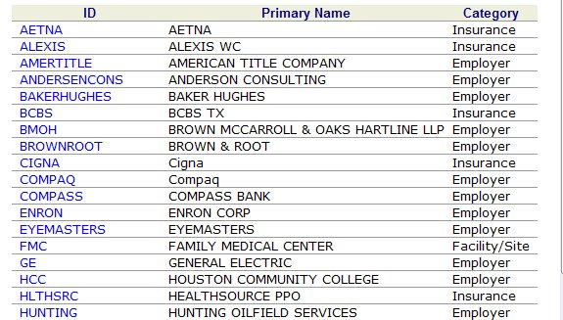
Fig 1c

Edit:
- Ensure that results are in alphabetical order by Primary Name.
- Change name of Category column to Type. (This is the name of the field in Add-Assoc. Provider).
- The only items listed in Column 3 (Category) are Associate Providers and Main Org.
- When user clicks hyperlink, the application should pull [org id] into the Site organization field at Add-a-Fee Schedule Dialogue.

Look up Parent Fee Schedule: This look up takes user to a search engine for an existing Fee schedule. The user should be able to pull up using the following criteria:
Fee Schedule Name, Fee Schedule ID, Description, Physicians linked to Fee Schedule, Locations linked to Fee schedule
Fee Schedule Name
Fee Schedule ID | **User enters ID
Description
Associated Physicians | **User enters ID(s)
Associated Site Organizations | **User enters ID(s)

Once user clicks [OK]→application pulls up results:

- User clicks look up→application takes user to search engine→user clicks Name/Description (Fee Schedule 2000)→application takes user to details of fee schedule
This is a view only screen. User closes screen→application takes user back to results→ if user sees the fee schedule for Parent Fee schedule, user clicks Fee Schedule ID→ Application pulls Fee Schedule ID into field for Parent Fee Schedule ID.

Or
User clicks look up→application takes user to search engine→user does not see desired results and closes results window→application takes user back to Add-Fee-Schedule dialogue.

Next Action:

Once the user completes all necessary fields in Add-a-Fee Schedule Dialogue, they should choose a Next Action (see below)
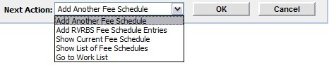
Add:
- Add fee schedule items
- Return to Home

Edit:
- Change Show Current Fee Schedule to View Fee Schedule
- Change Show List of Fee Schedules to Go to Search

Add Another Fee Schedule: Takes user to Add-a-Fee Schedule Dialogue
Add RVRBS Fee Schedule Entries: Takes user to Dialogue for Add-Fee Schedule Entries
Add Fee Schedule Items: Takes user to Add-Fee Schedule Items Dialogue
View Fee Schedule: Takes user to summary page for Fee Schedule
Go to Search: Takes user to search engine for Fee Schedules
Return to Home: Takes user to their Home Page
Go to Work list: Takes user to their Work List

Function:

User Clicks [OK] → Application adds Fee Schedule to Main Org→ Application performs Next Action.

